Enthalpy Recap

Read the Quantitation of Energy Notes from Unit 6

1. First Law of Thermodynamics

Conservation of energy-For an exothermic reaction, “lost” heat from the system goes into the surroundings.

There are two ways energy is “lost” from a system:

Converted to heat, q

Used to do work, w

Energy conservation requires that the energy change in the system is equal to the heat released plus work done.

∆E = q + w

∆E = ∆H + P∆V

∆E is a state function. Internal energy change independent of how done

2. Thermodynamics and Spontaneity

Spontaneity- is whether a process (chemical reaction) will occur.

Spontaneous= occurs without outside intervention. The new term for this is thermodynamically favored.

Nonspontaneous = will not occur unless there is outside intervention, thermodynamically unfavored. Needs energy.

Spontaneity is determined by comparing the chemical potential energy of the system before the reaction with the free energy of the system after the reaction.

If the system after reaction has less potential energy than before the reaction, the reaction is thermodynamically favorable.

Spontaneity does not tell the RATE of a reaction. C(diamond) 🡪C(graphite). This is thermodynamically favored reaction. But happily for all those who own a diamond, the rate is very slow. A thermodynamically favored reaction that does not proceed at as measureable rate is said to be under “kinetic control.”

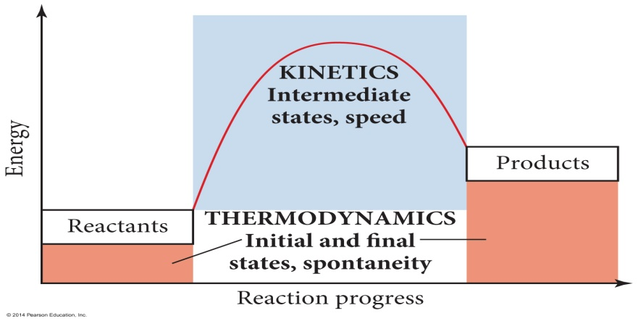

3. Spontaneity and Reversibility

Any spontaneous process is irreversible because there is a net release of energy when it proceeds in that direction. It will proceed in only one direction.

A reversible process will proceed back and forth between the two end conditions. Any reversible process is at equilibrium. This results in no change in free energy.

If a process is spontaneous in one direction, it must be nonspontaneous in the opposite direction.

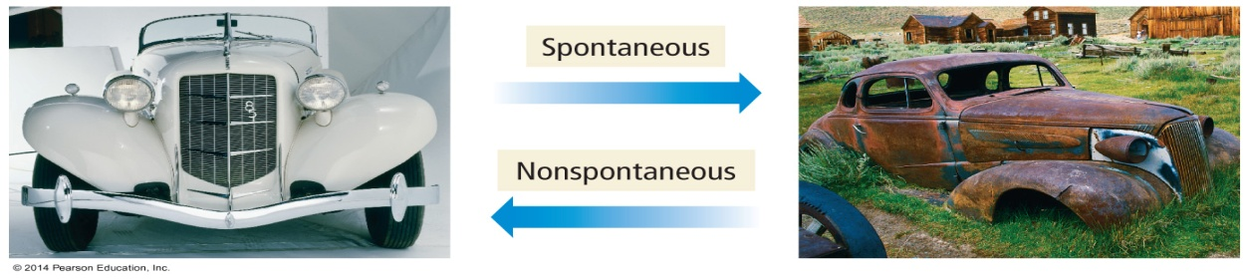

4. Endothermic Spontaneous Processes

Spontaneous processes occur because they release energy from the system.

Most spontaneous processes proceed from a system of higher potential energy to a system at lower potential energy.

**Exothermic**

But there are some spontaneous processes that proceed from a system of lower potential energy to a system at higher potential energy.

**Endothermic**

How can something absorb potential energy, yet have a net release of energy? The answer is an increase in disorder.

5. **Entropy**- A state function which is a measure of the randomness or disorder of a system. It is a measure of the probability of the number of arrangements available to a system. The greater the possible arrangements, the greater the entropy.

a. ΔSsystem = ΔSfinal - ΔSinitial

b. ΔSsystem= Positive= increase in entropy = process is *generally s*pontaneous

c. ΔSsystem = Negative = decrease in entropy = process is *generally* not spontaneous

4. Determining the sign of entropy. Entropy will increase when

a. A change in state Solid🡪Liquid🡪Gas

ΔS < ΔS < ΔS

b. Temperature increasing 10◦ C → 100◦C

ΔS < ΔS

c. When solids dissolve NaCl(s) → NaCl (aq)

ΔS < ΔS

d. When # of gas particles increase

2SO3 → 2SO2 + O2

ΔS < ΔS

e. When molecular complexity increases

KCl vs CaCl2

ΔS < ΔS

f. More atoms more entropy

CH4 vs C2H4

ΔS < ΔS

**Exercise 2 Predicting Entropy Changes**

Predict the sign of the entropy change for each of the following processes.

A: Solid sugar is added to water to form a solution.

B: Iodine vapor condenses on a cold surface to form crystals.

**A: +∆*S***

**B: -∆*S***

*Sample Problem A:*

Which of the following has the **largest** increase in entropy?

1. CO2(s) 🡪 CO2(g)
2. H2(g) + Cl2(g) 🡪 2 HCl(g)
3. KNO3(l) 🡪 KNO3(s)
4. C(diamond) 🡪 C(graphite)

*Answer:*  a) the substance changes from a highly organized state to a more disorganized state.

5. Calculating Entropy from tables of standard values

a. Units are J/Kmol

b. **ΔSrxn = Σ ΔS (products) - Σ ΔS (reactants)**

*Sample Problem B:*

Calculate the entropy change at 25°C, in J/K for:

2 SO2(g)  + O2(g) 🡪 2 SO3(g)

Given the following data:

SO2(g)  248.1 J/K mol

O2(g) 205.3 J/Kmol

SO3(g) 256.6 J/K mol

An*swer*: --191.9 J/K